8 Queen Problem
Aim
To solve the 8-Queen Problem using Backtracking in Python such that no two queens attack each other.
Algorithm
- Start from the first column.
- Place a queen in each row one by one.
- Check whether the queen is safe:
  - No other queen in the same row.
  - No queen in the upper-left diagonal.
  - No queen in the lower-left diagonal.
- If safe, place the queen and move to the next column.
- If no position is safe, backtrack and try another row.
- Repeat until all 8 queens are placed.
Python Code
N = 8

def print_board(board):
for row in board:
print(" ".join("Q" if x == 1 else "." for x in row))

def is_safe(board, row, col):
# Check left side of row
for i in range(col):
if board[row][i] == 1:
return False

# Check upper-left diagonal
i, j = row, col
while i >= 0 and j >= 0:
if board[i][j] == 1:
return False
i -= 1
j -= 1

# Check lower-left diagonal
i, j = row, col
while i < N and j >= 0:
if board[i][j] == 1:
return False
i += 1
j -= 1

return True

def solve(board, col):
if col >= N:
return True

for i in range(N):
if is_safe(board, i, col):
board[i][col] = 1

if solve(board, col + 1):
return True

board[i][col] = 0

return False

board = [[0 for _ in range(N)] for _ in range(N)]

if solve(board, 0):
print("Solution Found:\n")
print_board(board)
else:
print("No Solution Exists")

Output
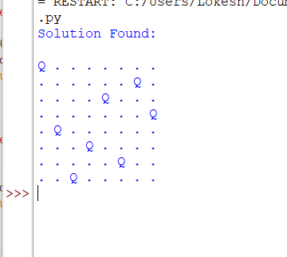
Result
Thus, The 8-Queen Problem was successfully solved using the Backtracking Algorithm in Python.

